**Chapter 2: Probability**

A **random experiment** is a mechanism that **produces a definite outcome** that **cannot be predicted** with certainty.  
Ex: Rolling a dice. There can be 6 possible outcomes {1, 2, 3, 4, 5, 6}. However, none of the outcomes can be exactly predicted.  
🡪 Rolling a dice: a random experiment

When a random experiment is repeated many times each one is known as **a trial**.  
Ex: roll a dice once: a trial.

The **sample space S** of a random experiment is the **collection of all possible outcomes**.  
 Ex: Roll a dice and record number dots. 🡪 $S=\{1, 2, 3, 4, 5, 6\}$

An **event E** associated with a random experiment is a **subset of the sample space**.  
 Ex: $E_{1}=\left\{6\right\}, E_{2}=\left\{even\right\}=\{2, 4, 6\}$

The **probability P** of any outcome is a number **between 0 and 1**. 0 <= P <= 1  
The probabilities of all the outcomes add up to 1.   
The **probability of an event** is **the sum of the probabilities of the outcomes in E**.  
Ex: X: number of dots when tossing a dice.

$E_{1}=\left\{6\right\}$

$E_{2}=\left\{even\right\}=\{2, 4, 6\}$

$P\left(E_{1}\right)=\frac{|E_{1}|}{\left|S\right|}=\frac{1}{6}, P\left(E_{2}\right)=\frac{|E_{2}|}{\left|S\right|}=\frac{3}{6}$

$P\left(E_{1}\right)=P\left(X=1\right)=\frac{1}{6}$

$P\left(E_{2}\right)=P\left(X=2\right)+P\left(X=4\right)+P\left(X=6\right)=\frac{1}{6}+\frac{1}{6}+\frac{1}{6}=\frac{3}{6}$

Ex2: 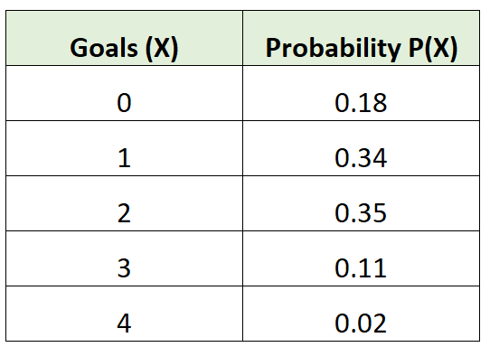🡪 probability distribution

$E_{3}:number of goals>2$

$P\left(E_{3}\right)=P\left(X>2\right)=P\left(X=3\right)+P\left(X=4\right)=0.11+0.02$

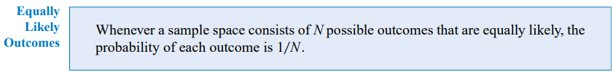

-------------------------------------------------------------------------------------------------------------------------------

**Basic set operations**

The **union** of two events is the event that consists of **all outcomes that are contained in either of the two events**. We denote the union as ***E*1∪*E*2**. or

The **intersection** of two events is the event that consists **of all outcomes that are contained in two events**. We denote the intersection as ***E*1∩*E*2**. and

The **complement of an event** in a sample space is the set of outcomes in the sample space that are not in the event. We denote the component of the event E as E’.

-------------------------------------------------------------------------------------------------------------------------------**Permutations** relates to the act of **arranging all the members of a set into some sequence or order**.   
Ex: Picking first, second and third place winners.

**Combinations** is a way of **selecting items from a collection**, such that (unlike permutations) **the order of selection does not matter**.  
Ex: Picking three winners.

**Additional rule**



union, P(A or B) = P(A) + P(B) - P(A and B)

**Mutually exclusive (disjoint)**

**Events A and B** are said to be **mutually exclusive** if it is **not possible** that **both occur at the same time**.   
Ex: Toss of a coin.   
 Let A be the event that the coin lands on heads  
 Let B be the event that the coin lands on tails.   
 🡪 In a single fair coin toss, events A and B are mutually exclusive. 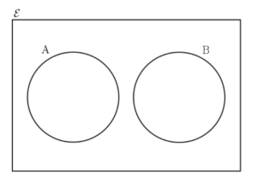

A and B are mutually exclusive

→ $P(A and B) =P\left(A∩B\right)=0$

→ $P(A or B)=P\left(A∪B\right)=P\left(A\right)+P\left(B\right)-P\left(A∩B\right)=P\left(A\right)+P\left(B\right)-0=P\left(A\right)+P(B)$**Independent**

**Events A and B** are said to be i**ndependent** if the **probability of B occurring is unaffected by the occurrence of the event A happening**.   
Ex: Tossing a coin twice.   
 Let A be the event that the first coin toss lands on heads.   
 Let B be the event that the second coin toss lands on heads.   
 🡪 Clearly the result of the first coin toss does not affect the result of the second coin toss.  
 🡪 Events A and B are independent.

A and B are independent

→ $P(A and B)=P\left(A∩B\right)=P\left(A\right)*P(B)$

→ $P(A or B)=P\left(A∪B\right)=P\left(A\right)+P\left(B\right)-P\left(A∩B\right)=P\left(A\right)+P\left(B\right)-P\left(A\right)*P(B)$

**-------------------------------------------------------------------------------------------------------------------------------Conditional probability** keyword *if, *given that **🡪 Decision tree**

